07 Laser-transmit Module Module

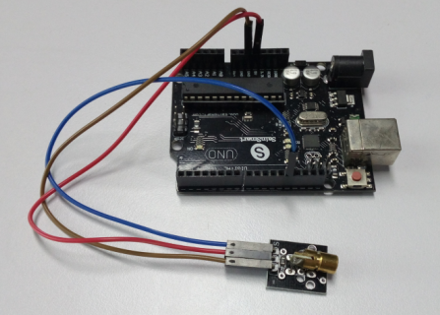

void setup()

{

pinMode(13, OUTPUT); //define the digital output interface 13 feet

}

void loop() {

digitalWrite(13, HIGH); // open the laser head

delay(1000);// delay one second

digitalWrite(13, LOW); // turn off the laser head

delay(1000); // delay one second

}